**Project Design Phase**

**Problem – Solution Fit Template**

|  |  |
| --- | --- |
| Date | 15 February 2025 |
| Team ID | LTVIP2025TMID32623 |
| Project Name | Enchanted Wings: Marvels of Butterfly Species |
| Maximum Marks | 2 Marks |

**Problem – Solution Fit Template:**

Public understanding and appreciation of butterfly species is limited, leading to under-supported conservation efforts, declining pollinator populations, and missed educational opportunities about biodiversity, metamorphosis, and ecological balance.

*Enchanted Wings: Marvels of Butterfly Species* provides a compelling, visually rich, and scientifically accurate platform that educates audiences about the beauty, biology, and importance of butterflies—fostering awareness, inspiring conservation action, and bridging the gap between wonder and environmental responsibility.

**Purpose:**

1. **Educate Audiences**
   * Provide accessible, engaging knowledge about butterfly species, their biology, life cycle, and ecological roles.
2. **Inspire Appreciation for Nature**
   * Showcase the aesthetic beauty and evolutionary marvels of butterflies to spark wonder and connection with the natural world.
3. **Promote Conservation Awareness**
   * Highlight the environmental threats butterflies face (habitat loss, climate change, pesticides) and encourage protective actions.
4. **Support Biodiversity Literacy**
   * Demonstrate how butterflies contribute to ecosystem health and pollination, making them key indicators of biodiversity.
5. **Encourage Citizen Engagement**
   * Motivate individuals to participate in butterfly-friendly gardening, local conservation efforts, or data collection (e.g., butterfly counts).
6. **Bridge Science and Storytelling**
   * Use visuals, facts, and narratives to turn scientific information into an emotionally resonant and memorable experience.
7. **Celebrate Global Diversity**
   * Feature species from around the world to illustrate the vast range of adaptations, habitats, and ecological roles butterflies hold.

**Template:**

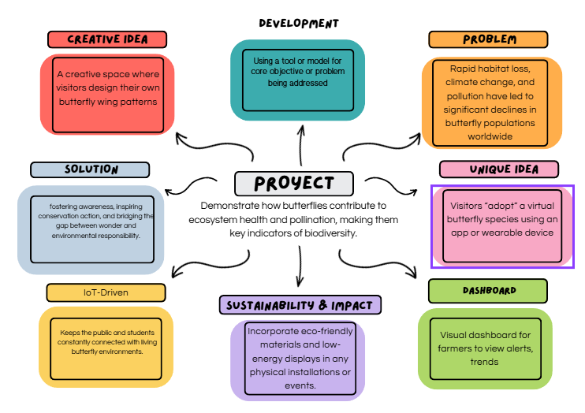

References:

1. <https://www.ideahackers.network/problem-solution-fit-canvas/>
2. <https://medium.com/@epicantus/problem-solution-fit-canvas-aa3dd59cb4fe>